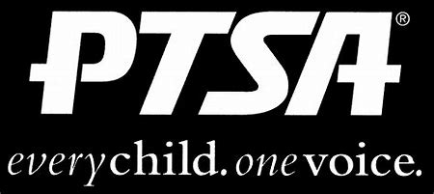
Royal Oak Middle School PTSA
January 19, 2021
Meeting Agenda (held via Zoom)

- Call to Order
Welcome and Pledge of Allegiance

- Secretary’s Report – Jason Vinluan
Approval of November 2020 Minutes

- Treasurer’s Report – Elizabeth Rummel

- Principal’s Report – Todd Noonan

- Board Member’s Report - Maryanne VanHaitsma

- President’s Report – Michelle Vinluan
  - Open chair positions:
    - Health and Wellness Chair or Co-Chairs
  - Founder’s Day
  - Nominating Committee
  - ROPAC (RO Parent Advisory Committee) virtual meeting on 2/3
  - Community Rewards (Thank you to these businesses for this support!)
    - Kroger (link your card online to ROMS PTA)
    - AmazonSmile (search for ROMS PTA to link to your account)
    - Toyology Toys (mention ROMS at checkout, in store or online)

- Membership Report – Joelle Jarrait
524 Members
Thank you to Jeffery Sauger Photography for business membership

- Teacher Representative/Student Council Report – Lindsay Potterack

- Student Representative – Finn Rossbach

- Committee Reports
  - Reflections
  - Staff Appreciation

- Old Business
  - ROMS PTA will partner with Student Council to purchase and present a memorial gift for Sarah Klaus once we can get back to school/grounds.

- New Business

- Adjournment
Next Meeting: Monday, March 15, 2021 at 7 p.m.

