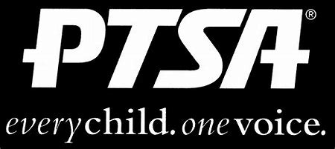
Royal Oak Middle School PTSA
November 16, 2020
Meeting Agenda (held via Zoom)

- Call to Order
Welcome and Pledge of Allegiance

- Secretary’s Report – Jason Vinluan
Approval of October 2020 Minutes

- Treasurer’s Report – Elizabeth Rummel

- Principal’s Report – Todd Noonan

- Board Member’s Report - Maryanne VanHaitsma

- President’s Report – Michelle Vinluan
  - Thank you:
Mrs. Sells Mathes and Becky Bibbs for co-chairing the book fair
Val Moskalik for chairing Diversity & Inclusion
  - Open chair positions:
    - Staff Appreciation Chair or Co-Chairs
    - Health and Wellness Chair or Co-Chairs
  - Holiday Help
  - Donations to ROYA, Blessing in a Backpack, etc.?
  - Spirit wear online store is open until November 29th https://stores.inksoft.com/roms_webstore/shop/home

- Membership Report –
516 Members
Thank you to Jeffery Sauger Photography for business membership

- Teacher Representative/Student Council Report – Lindsay Potterack

- Student Representative – Finn Rossbach

- Committee Reports
  - Reflections

- Old Business
  - ROMS PTA will partner with Student Council to purchase and present a memorial gift for Sarah Klaus once we can get back to school/grounds.

- New Business

- Adjournment
Next Meeting: Tuesday, January 19, 2021 at 7 p.m.

