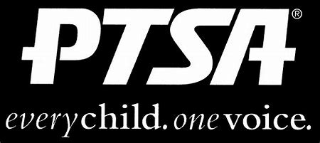
Royal Oak Middle School PTSA
November 18, 2019
Meeting Agenda

- Call to Order
Welcome and Pledge of Allegiance

- Secretary’s Report – Jason Vinluan
Approval of October 2019 Minutes

- Treasurer’s Report – Sarah Garcia

- Principal’s Report – Todd Noonan

- Board Member’s Report - Maryanne VanHaitsma

- President’s Report – Michelle Vinluan
  - Facebook closed group: membership is required by December 1st to remain in the group
  - Thank you:
    - Leah Barnett for planning the meals during conferences for Staff Appreciation
    - Susan Bannan ,Colleen Dillon, Katie JoAnne Graham, Megan O’Shea and Julie Snook for an amazing and successful Dawg Walk
    - Amy Gaynier for submitting Box Tops. ROMS PTSA earned $65.00

- Membership Report – Rose Castilla
488 Members

- Teacher Representative/Student Council Report – Kerry Derminer

- Student Representative – Finn Rossbach

- Committee Reports
Book Fair: December 2nd – 10th. All proceeds go toward books, shelves, and supplies for our classroom libraries.
Reflections: Entries due December 3rd
Founder’s Day: Kerry Derminer
ROYA Bowl-A-Thon: March 1st

- Old Business

- New Business
Raffle: Thank you to Tom’s Oyster Bar for donating a $25 gift card!

- Adjournment
Next Meeting: Monday, December 16, 2019 at 7 p.m. in the Learning Commons

