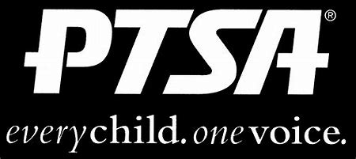
Royal Oak Middle School PTSA
December 16, 2019
Meeting Agenda

- Call to Order
Welcome and Pledge of Allegiance

- Secretary’s Report – Jason Vinluan
Approval of November 2019 Minutes

- Treasurer’s Report – Sarah Garcia

- Principal’s Report – Todd Noonan

- Board Member’s Report - Maryanne VanHaitsma

- President’s Report – Michelle Vinluan
  - Founder’s Day is February 3rd at Club Venetian. Cost is $31.00 and will need to be collected by January 25th. ROMS PTSA will pay ½ for the first 5 teachers and first 5 members (not in the executive board). Can nominate members for awards.
  - ROYA Bowl-A-Thon is March 1st. Registration is open, $500 for teams of 5.
  - Thank you:
    - Mrs. Schultz, Jenni Tracy and all volunteers for providing ROMS with the Scholastic Book Fair
    - Tressa Orthmeyer for the Reflections Art Contest
  - Memorial gift for Sarah Klaus

- Membership Report – Rose Castilla
543 Members, last year we had 492!

- Teacher Representative/Student Council Report – Kerry Derminer

- Student Representative – Finn Rossbach

- Committee Reports
  - Reflections

- Old Business

- New Business
Raffle: Thank you to St. Julian Winery for donating!

- Adjournment
Next Meeting: Monday, March 16, 2019 at 7 p.m. in the Learning Commons (no meetings in January – MLK Day or February – Winter Break)

