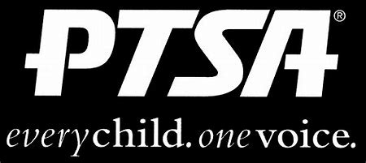
Royal Oak Middle School PTSA
May 17, 2021
Meeting Agenda (held via Zoom)

- Call to Order
Welcome and Pledge of Allegiance

- Secretary’s Report – Jason Vinluan
Approval of April 2021 Minutes

- Treasurer’s Report – Elizabeth Rummel
April Reconciliation Summary and Reconciliation Detail

- Principal’s Report – Todd Noonan

- Board Member’s Report - Maryanne VanHaitsma

- President’s Report – Michelle Vinluan
  - Thank you to the 2020-21 executive board and committee chairs!!!
  - Committee Chairs – please email me if you are not chairing for 2021-22
  - Board voted to increase Staff Appreciation budget by $100 to cover the increase of staff, compared to last year

- Membership Report – Joelle Jarrait
532 Members
Thank you to Jeffery Sauger Photography for business membership

- Teacher Representative/Student Council Report – Lindsay Potterack

- Committee Reports
Staff Appreciation – all ROMS staff members received a $25 gift card (Proving Grounds, Toyology, Emagine, Rail & Anchor, Papertrail Books). There were 4 donated gift baskets (Panda Express, Proving Grounds, Toyology, Emagine) that were also raffled off. Thank you to Jason Vinluan for helping!

- Old Business
ROMS PTA will partner with Student Council to purchase and present a memorial gift for Sarah Klaus once we can get back to school/grounds.

- New Business

- Adjournment
Next meeting: Monday, September 20, 2021 at 7 p.m.

