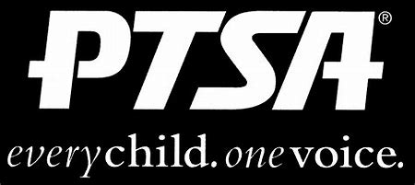
Royal Oak Middle School PTSA
May 18, 2020
Meeting Agenda (held via Zoom)

- Call to Order
Welcome and Pledge of Allegiance

- Secretary’s Report – Jason Vinluan
Approval of December 2019 Minutes

- Treasurer’s Report – Sarah Garcia
  - Please be sure to submit any receipts for reimbursement as soon as possible

- Principal’s Report – Todd Noonan

- Board Member’s Report - Maryanne VanHaitsma

- President’s Report – Michelle Vinluan
  - 2020 Census
  - Congratulations to the following students for receiving awards for their Reflections entries at the state level:
Kira P. Outstanding Interpretation Honorable Mention Award for Literature
Josi H. Outstanding Interpretation Honorable Mention Award for Visual Art
  - Congratulations to Kathy Knapp for being the recipient of the Lifetime Achievement Award at the Founder’s Day dinner.
  - Thank you:
Jill Pickering for completing the Green Schools application!
Jenni Tracy for chairing another ROMS book fair!
Sarah Garcia, Amy Gaynier and Peter Haun for serving on the PTA executive board this past year!
  - In place of the 8th grade dance and promotion celebration, the PTA has purchased yard signs that will be given to each student.

- Membership Report – Rose Castilla
551 Members, last year we had 492!

- Teacher Representative/Student Council Report – Kerry Derminer

- Student Representative – Finn Rossbach
No Report

- Committee Reports
  - ROMS Nominating Committee presentation of the slate and vote on new officers

- Old Business
  - ROMS PTA will partner with Student Council to purchase and present a memorial gift for Sarah Klaus once we can get back to school/grounds.

- New Business

- Adjournment
Next Meeting: Monday, September 21, 2020 at 7 p.m. in the Learning Commons (I hope!)

