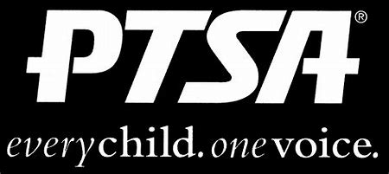
Royal Oak Middle School PTSA
September 21, 2020
Meeting Agenda (held via Zoom)

- Call to Order
Welcome and Pledge of Allegiance
Introduction of PTA Executive Board
Presentation by Administrators and Teachers

- Secretary’s Report – Jason Vinluan
Approval of May 2020 Minutes

- Treasurer’s Report – Elizabeth Rummel
  - Present and vote on 2020-21 budget

- Principal’s Report – Todd Noonan

- Board Member’s Report - Maryanne VanHaitsma

- President’s Report – Michelle Vinluan
  - Open chair positions:
    - Book Fair Co-Chair (with Mrs. Shultz)
    - Health and Wellness
    - Diversity & Inclusion
  - Open VP Membership position. Vote in Joelle Jarrait.
  - Please join the PTA, if you haven’t already. Access to the FB group and future meeting links will only be available to members.
  - Washington DC Funds that were returned due to the cancelled trip are remaining in individual student accounts to be used to reimburse families for pay to play sports and other school related costs. More information to come.

- Membership Report –
374 Members
Acknowledged by the Michigan PTA for 19-20 memberships and asked to participate in membership webinar with Michigan PTA to share our positive experience.

- Teacher Representative/Student Council Report – Lindsay Potterack

- Student Representative – Finn Rossbach

- Committee Reports

- Old Business
  - ROMS PTA will partner with Student Council to purchase and present a memorial gift for Sarah Klaus once we can get back to school/grounds.

- New Business

- Adjournment
Next Meeting: Monday, October 19, 2020 at 7 p.m. on Zoom

